DBMS Transaction Management: ACID Properties, Schedule

What is a Database Transaction?
A transaction is a logical unit of processing in a DBMS which entails one or more database access operation. In a nutshell, database transactions represent real-world events of any enterprise.
All types of database access operation which are held between the beginning and end transaction statements are considered as a single logical transaction. During the transaction the database is inconsistent. Only once the database is committed the state is changed from one consistent state to another.
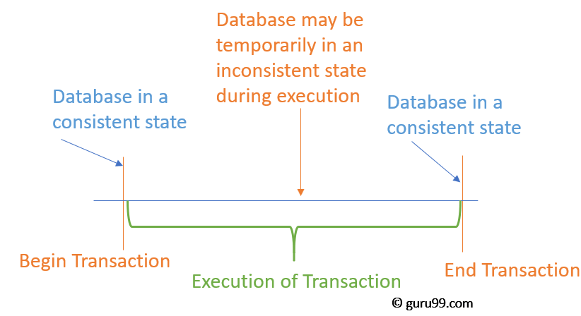
In this tutorial, you will learn:
- What is a Database Transaction?
- Facts about Database Transactions
- Why do you need concurrency in Transactions?
- States of Transactions
- What are ACID Properties?
- Types of Transactions
- What is a Schedule?

Facts about Database Transactions
- A transaction is a program unit whose execution may or may not change the contents of a database.
- The transaction is executed as a single unit
- If the database operations do not update the database but only retrieve data, this type of transaction is called a read-only transaction.
- A successful transaction can change the database from one CONSISTENT STATE to another
- DBMS transactions must be atomic, consistent, isolated and durable
- If the database were in an inconsistent state before a transaction, it would remain in the inconsistent state after the transaction.

Why do you need concurrency in Transactions?
A database is a shared resource accessed. It is used by many users and processes concurrently. For example, the banking system, railway, and air reservations systems, stock market monitoring, supermarket inventory, and checkouts, etc.
Not managing concurrent access may create issues like:
- Hardware failure and system crashes
- Concurrent execution of the same transaction, deadlock, or slow performance

States of Transactions
The various states of a Database Transaction are listed below
State | Transaction types
Active State | A transaction enters into an active state when the execution process begins. During this state read or write operations can be performed.
Partially Committed | A transaction goes into the partially committed state after the end of a transaction.
Committed State | When the transaction is committed to state, it has already completed its execution successfully. Moreover, all of its changes are recorded to the database permanently.
Failed State | A transaction considers failed when any one of the checks fails or if the transaction is aborted while it is in the active state.
Terminated State | State of transaction reaches terminated state when certain transactions which are leaving the system can't be restarted.
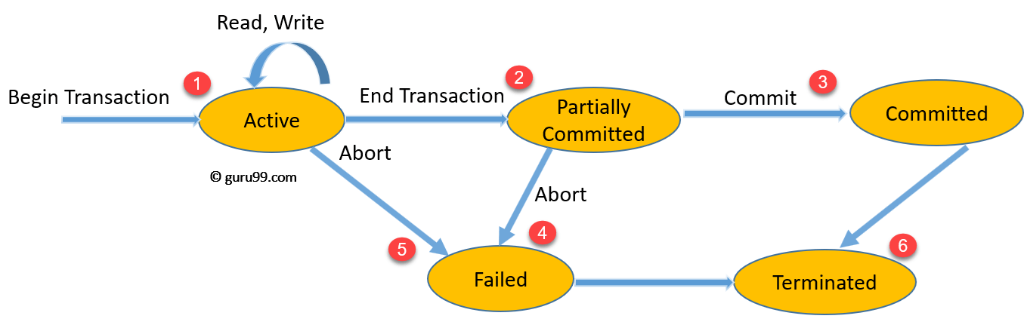State Transition Diagram for a Database Transaction
Let's study a state transition diagram that highlights how a transaction moves between these various states.
- Once a transaction states execution, it becomes active. It can issue READ or WRITE operation.
- Once the READ and WRITE operations complete, the transactions becomes partially committed state.
- Next, some recovery protocols need to ensure that a system failure will not result in an inability to record changes in the transaction permanently. If this check is a success, the transaction commits and enters into the committed state.
- If the check is a fail, the transaction goes to the Failed state.
- If the transaction is aborted while it's in the active state, it goes to the failed state. The transaction should be rolled back to undo the effect of its write operations on the database.
- The terminated state refers to the transaction leaving the system.

What are ACID Properties?
For maintaining the integrity of data, the DBMS system you have to ensure ACID properties. ACID stands for Atomicity, Consistency, Isolation, and Durability.
- Atomicity: A transaction is a single unit of operation. You either execute it entirely or do not execute it at all. There cannot be partial execution.
- Consistency: Once the transaction is executed, it should move from one consistent state to another.
- Isolation: Transaction should be executed in isolation from other transactions (no Locks). During concurrent transaction execution, intermediate transaction results from simultaneously executed transactions should not be made available to each other. (Level 0,1,2,3)
- Durability: · After successful completion of a transaction, the changes in the database should persist. Even in the case of system failures.

Example of ACID
Transaction 1: Begin X=X+50, Y = Y-50 END
Transaction 2: Begin X=1.1*X, Y=1.1*Y END
Transaction 1 is transferring $50 from account X to account Y.
Transaction 2 is crediting each account with a 10% interest payment.
If both transactions are submitted together, there is no guarantee that the Transaction 1 will execute before Transaction 2 or vice versa. Irrespective of the order, the result must be as if the transactions take place serially one after the other.

Types of Transactions
Based on Application areas
- Non-distributed vs. distributed
- Compensating transactions
- Transactions Timing
- On-line vs. batch
Based on Actions
- Two-step
- Restricted
- Action model
Based on Structure
- Flat or simple transactions: It consists of a sequence of primitive operations executed between a begin and end operations.
- Nested transactions: A transaction that contains other transactions.
- Workflow

What is a Schedule?
A Schedule is a process creating a single group of the multiple parallel transactions and executing them one by one. It should preserve the order in which the instructions appear in each transaction. If two transactions are executed at the same time, the result of one transaction may affect the output of other.
Example
Initial Product Quantity is 10
Transaction 1: Update Product Quantity to 50
Transaction 2: Read Product Quantity
If Transaction 2 is executed before Transaction 1, outdated information about the product quantity will be read. Hence, schedules are required.
Parallel execution in a database is inevitable. But, Parallel execution is permitted when there is an equivalence relation amongst the simultaneously executing transactions. This equivalence is of 3 Types.
RESULT EQUIVALENCE:
If two schedules display the same result after execution, it is called result equivalent schedule. They may offer the same result for some value and different results for another set of values. For example, one transaction updates the product quantity, while other updates customer details.
View Equivalence
View Equivalence occurs when the transaction in both the schedule performs a similar action. Example, one transaction inserts product details in the product table, while another transaction inserts product details in the archive table. The transaction is the same, but the tables are different.
CONFLICT Equivalence
In this case, two transactions update/view the same set of data. There is a conflict amongst transaction as the order of execution will affect the output.

What is Serializability?
Serializability is the process of search for a concurrent schedule who output is equal to a serial schedule where transaction ae execute one after the other. Depending on the type of schedules, there are two types of serializability:
- Conflict
- View

Summary:
- A transaction is a logical unit of processing in a DBMS which entails one or more database access operation
- It is a transaction is a program unit whose execution may or may not change the contents of a database.
- Not managing concurrent access may create issues like hardware failure and system crashes.
- Active, Partially Committed, Committed, Failed & Terminate are important transaction states.
- ACID stands for Atomicity, Consistency, Isolation, and Durability
- Three DBMS transactions types are Base on Application Areas, Action, & Structure.
- A Schedule is a process creating a single group of the multiple parallel transactions and executing them one by one.
- Serializability is the process of search for a concurrent schedule who output is equal to a serial schedule where transaction ae execute one after the other.

